Creativity and Calculation 2 By GM Bong Villamayor

Powerchess Asia

Answer following exercises using the previous tactical themes learned from your notes. This training if done regularly will enhance your creativity in generating tactics and deepen your calculating skill in the game.

1W 2W 3W
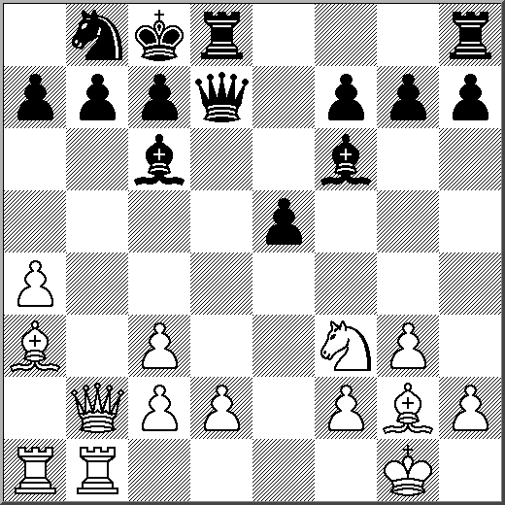
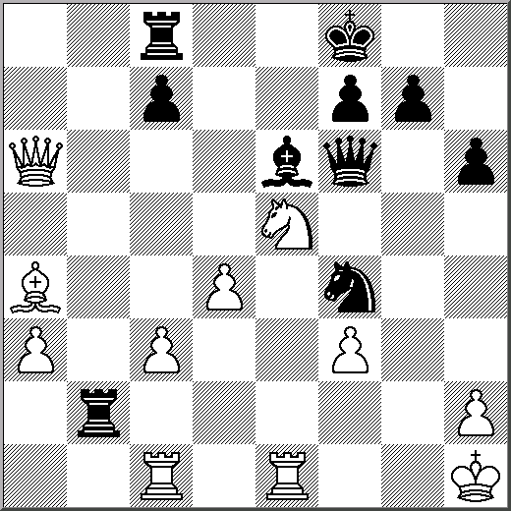
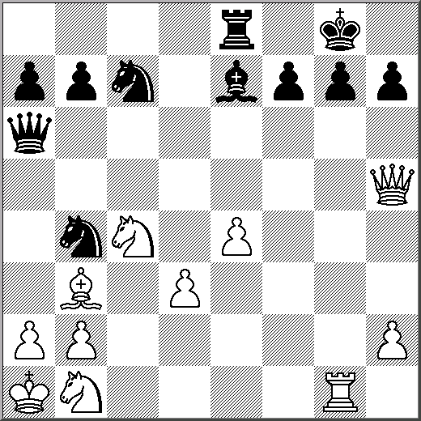

4W 5W 6W (1. Nf6+ or 1. Qxg7)
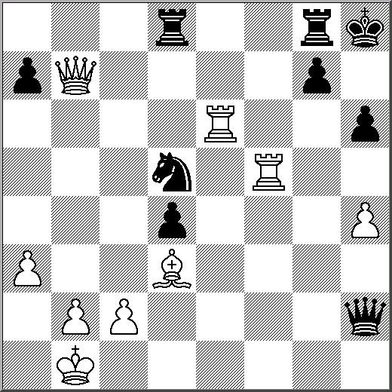
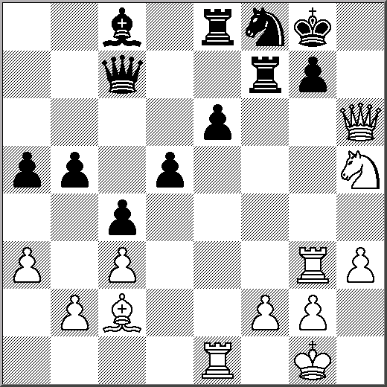
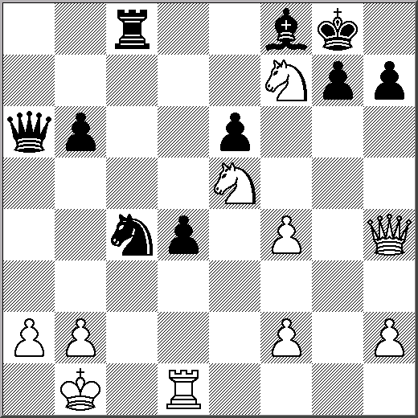

7W (1. Bh5 or 1. Rb4) 8W (1. Qh1+ or 1. Qa5) 9W (1. Qb3 or Qf8+)
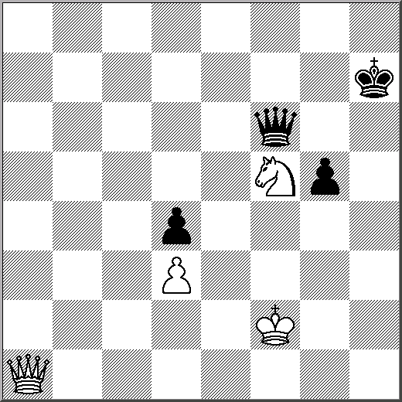
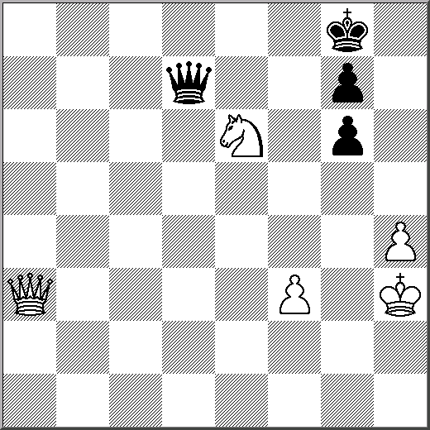
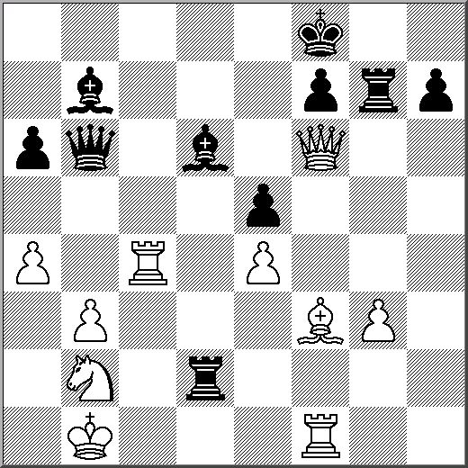

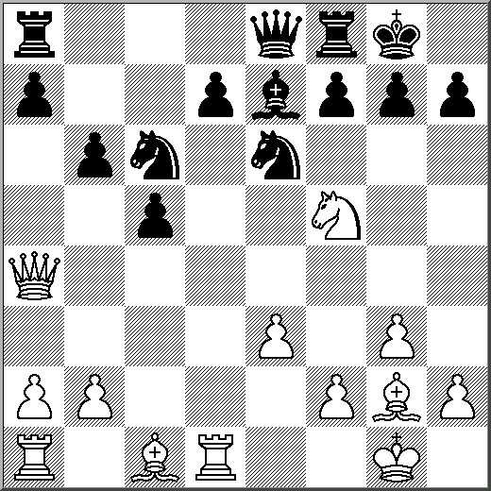
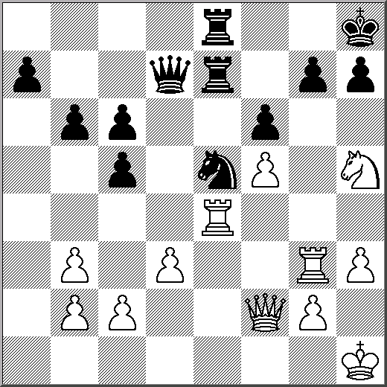
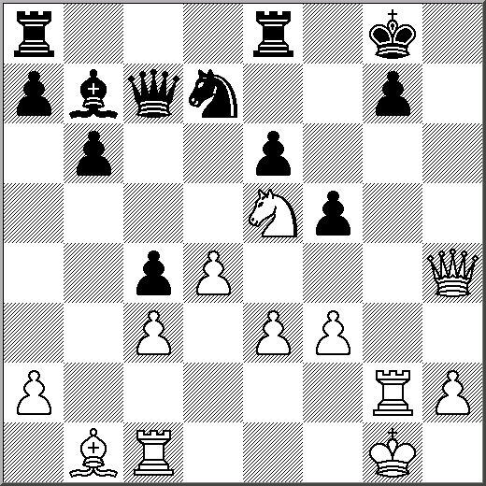
10W (1. Ng6 or Rxg7+) 11W (1. Nxg7 or 1. Rxg7) 12W (1. Rxd7 or 1. Bxc6)

